<$ScrKeepWithNext><$Scr_H::2><$Scr_Ps::0>
Compiler
<!$Scr_H::2><!$Scr_Ps::0>
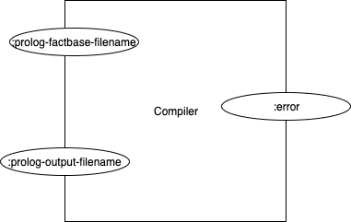
Figure <$n:figure:Compiler>

At the moment, the test version of the V2 compiler is a part with two inputs and one output.

The inputs are called <$Scr_Cs::1>:prolog-factbase-filename<!$Scr_Cs::1> and <$Scr_Cs::1>:prolog-output-filename<!$Scr_Cs::1> respectively.

The output is called <$Scr_Cs::1>:error<!$Scr_Cs::1>.

The intention of this (simple) design is that the V2 compiler test-bed accepts two filenames, as strings, on its inputs. If there is any problem, some kind of error event will come out of the <$Scr_Cs::1>:error<!$Scr_Cs::1> pin.

The input pin <$Scr_Cs::1>:prolog-factbase-filename<!$Scr_Cs::1> tells the test-bed to read the file with that name and convert it to some internal format.

The input pin <$Scr_Cs::1>:prolog-output-filename<!$Scr_Cs::1> tells the test-bed to write out the factbase to the given file name, when the test has completed. I remind myself that the output format of the factbase is “prolog”, since I want to tap into the V1 compiler using facts (prolog) that are compatible with the V1 internal format.

